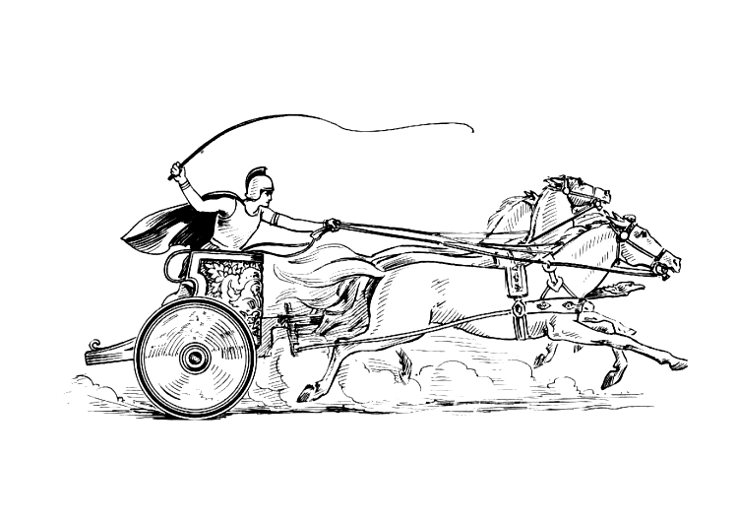Manduessedum - Mancetter Village (Place of War Chariots)
Mancetter Parish Council
Serving the People of Mancetter and Ridge Lane

You are invited to the Parish Council Meeting
to be held in the Schoolroom of St Peter’s Church Mancetter
on Tuesday 28th March 2023 at 7pm.

AGENDA

- Welcome and Apologies.

- Chairman’s request that anyone recording the meeting make themselves known, to allow
openness and recognise practicalities.

- Declared Notice of Interest by Councillors concerning Agenda Items.

- Public Question time of up to 15 Minutes for Parishioners to raise issues.

- Representation from County Highways to discuss ongoing local concerns,
regarding traffic volume and speeding through both villages, signage and pedestrian
safety.

An update will be given on Highways issues reported at the last Parish Council Meeting.

- Tree planting, Fencing and concerns over dog mess within the play area at Ridge Lane
recreation ground.

- Update from the Police, County and Borough Councillors.

- Minutes of the last meeting.

To accept the draft minutes of the Parish Council Meeting held on 24th January 2023.

- Matters Arising from the Parish Council Meeting on 24th January 2023 and items
not covered in any other Agenda points.

- Feedback from the Atherstone Surgery Patient Participation Group of 13th February 2023.

- Update on Levelling up Meeting held on 14th February 2023 and Cost of Living Agenda.
- North Warwickshire Area Committee Meeting information from 1st March 2023.

- Election process and 4th April deadline for submission of nomination papers.

- To note postponement of Annual Parish Meeting until 23rd May 2023, and record meeting dates for the forthcoming financial year.

- Allotment sharing scheme, waiting list allocation and land availability update.

- To discuss King Charles III Coronation events, competitions, badges and Floral displays within the Parish.

- Finance

- Signing of all payments since the last meeting in accordance with the Bank Mandate.
- To discuss a proposed change to the financial administration of the Parish Council.
- To note collection and banking of the allotment rents for the new financial year.
- Change of External Auditor for 2022 2023 Governance and Accountability Return.
- To approve costings of badges and plants for Kings Coronation celebrations.
- To agree Cemetery Fees for April 2023 – March 2024.

- Planning Matters and New Applications since the previous meeting

- Update on Approved, Rejected and Pending Applications and Appeals.

- Date of Planning hearing regarding the application at Barn Fishery confirmed as 6th June 2023 at the Council Offices.

- PAP/2022/0506 – Canal Cottage Quarry Lane Mancetter – Pending.

- PAP/2022/0481 – Whitehall Farm Atherstone Road Hartshill – Pending.

- To discuss any new applications received.
- PAP/2022/0641 – Dobbies Garden Centre
- PAP/2023/0044 – Unit 11 Manor Road
- PAP/2023/0062 – Whitehall Farm

- Cemetery and Maintenance around the Parish

- Tarmac Quarry maintenance work on the canal bridge in Quarry Lane.
- Repair work to Mill Lane footbridge.
- Update on parish noticeboards.
- Painting of cemetery railings.
- Installation of Jubilee Memorial Avenue signage within the cemetery.
- Review of cemetery rules.

- Date of next meeting- First Meeting of New Term of Office.
TUESDAY 16TH MAY 2023
7PM AT ST PETERS CHURCH SCHOOLROOM.

Signed
Date 23rd March 2023.
Elane Higgins
Parish Clerk Mancetter Memorial Hall Old Farm Road Mancetter CV9 1QN Tel: 01827 722552 / 07368 265051
Email: parishclerk@mancetter.org.uk
Website: www.mancetter.org.uk

